|  |  |  |
| --- | --- | --- |
| **Abstract**  **Introduction**  **Architecture (IP)**  **Architecture (ML)** | **Features -img enhance**  **- Auto correct**  **- Pdf to word**  **TechStack** | **Template matching**  **Result**  **Conclusion**  **References** |

**Abstract**

Problem Statement : A tool for fetching and editing information from a document mainly of image type

Need ? Unnecessary wastage of Human Resources, Time, Money

**Introduction**

Scan document, Choose template, Obtain in editable format

**Architecture**

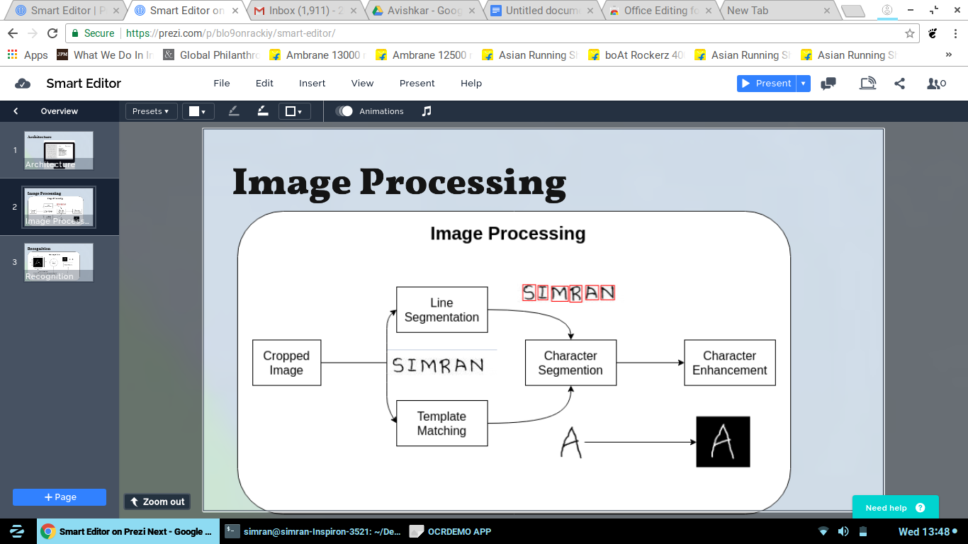

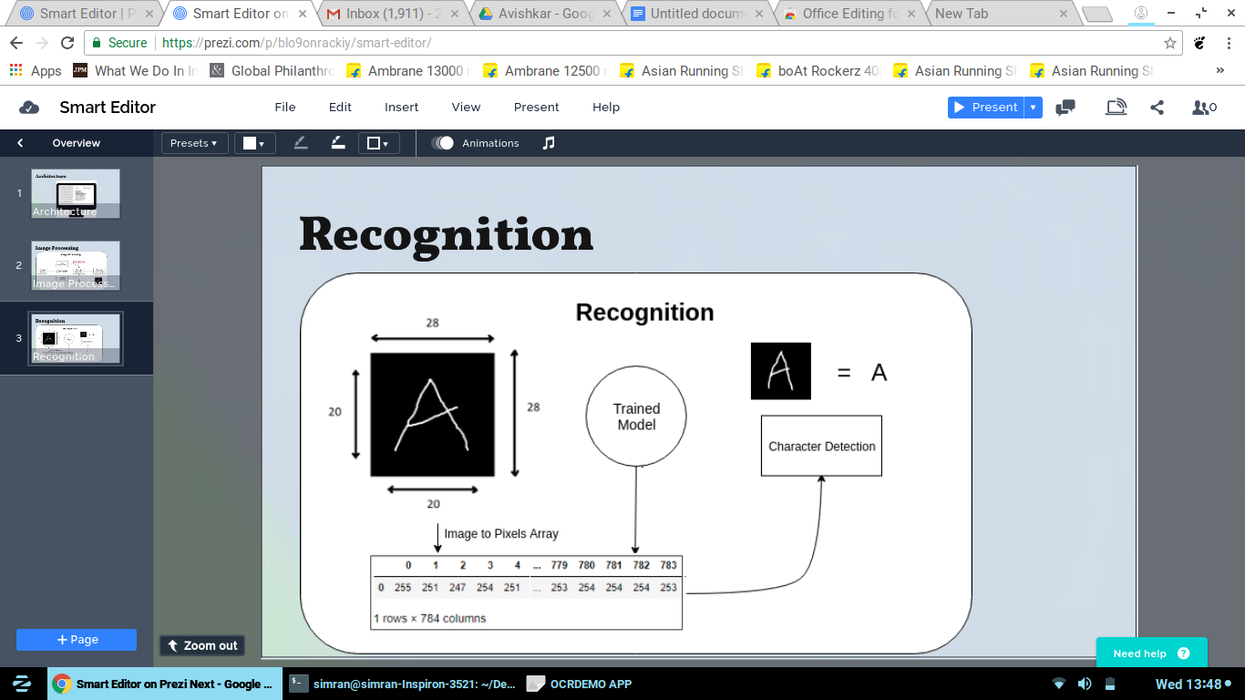

**Features**

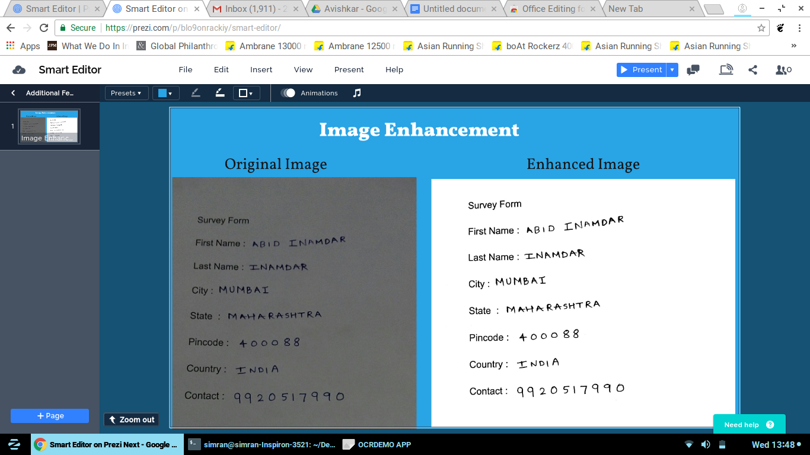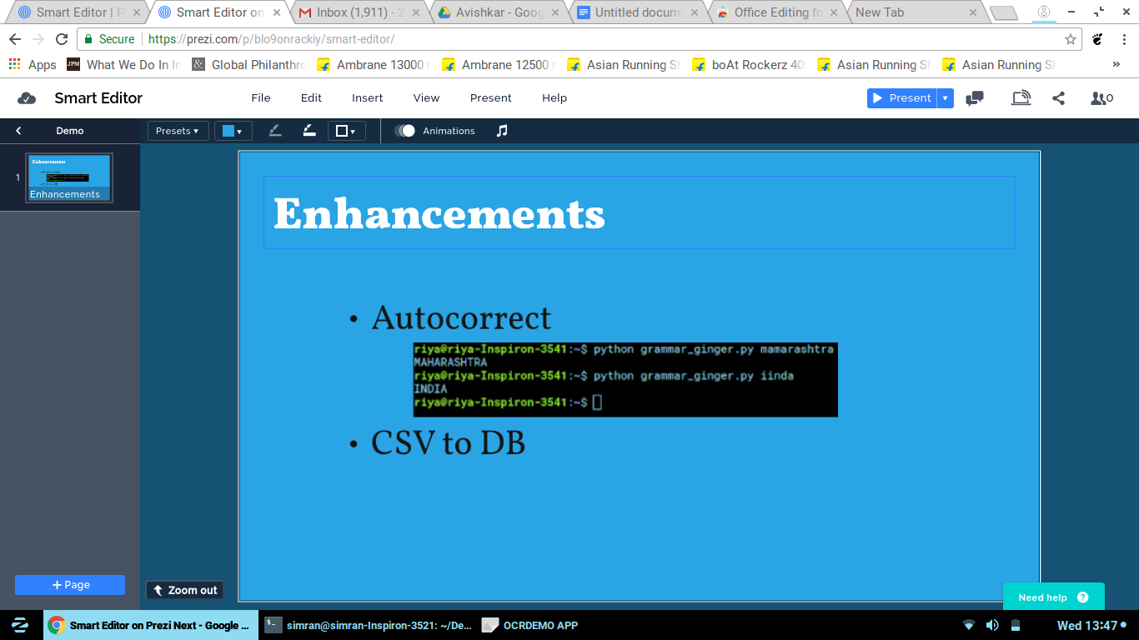

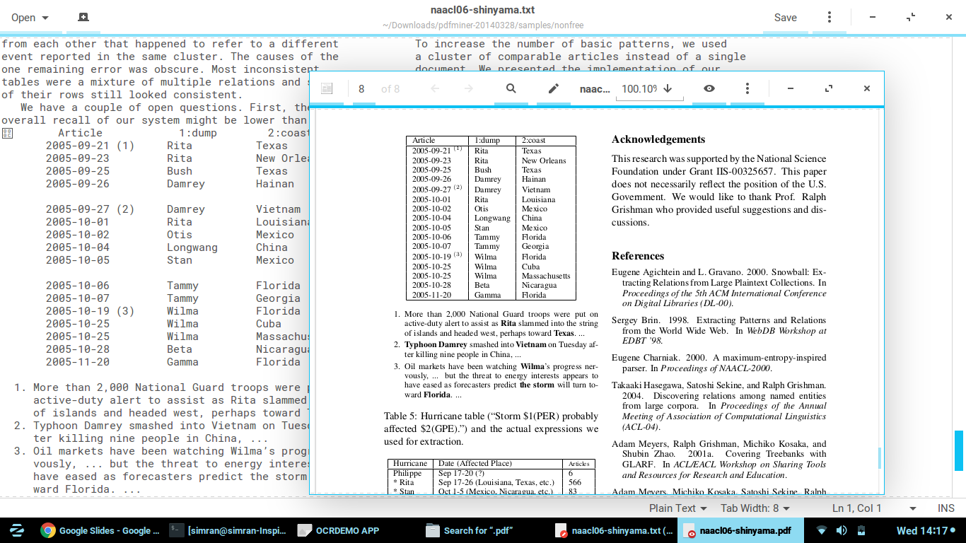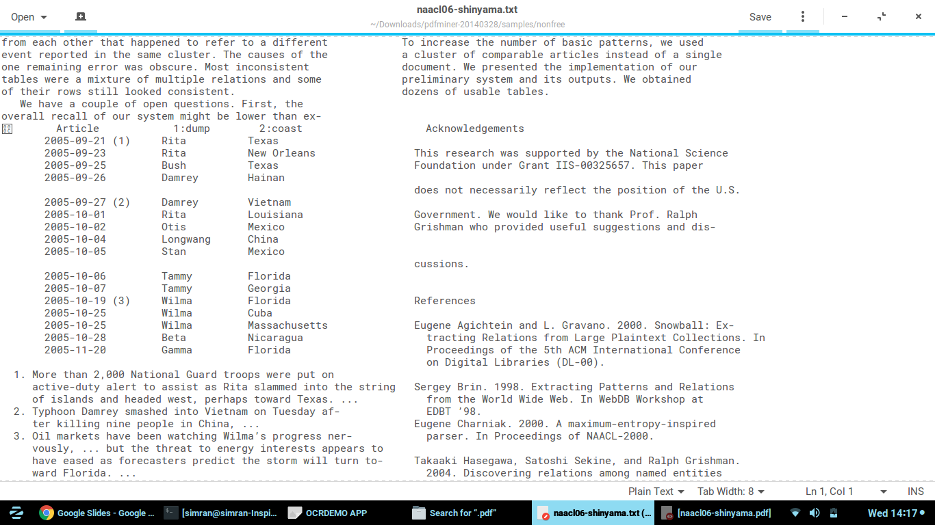

**TechStack**

Image Processing : OpenCV, Python

Training Model : Keras

Desktop GUI : Tkinter

**Template matching**

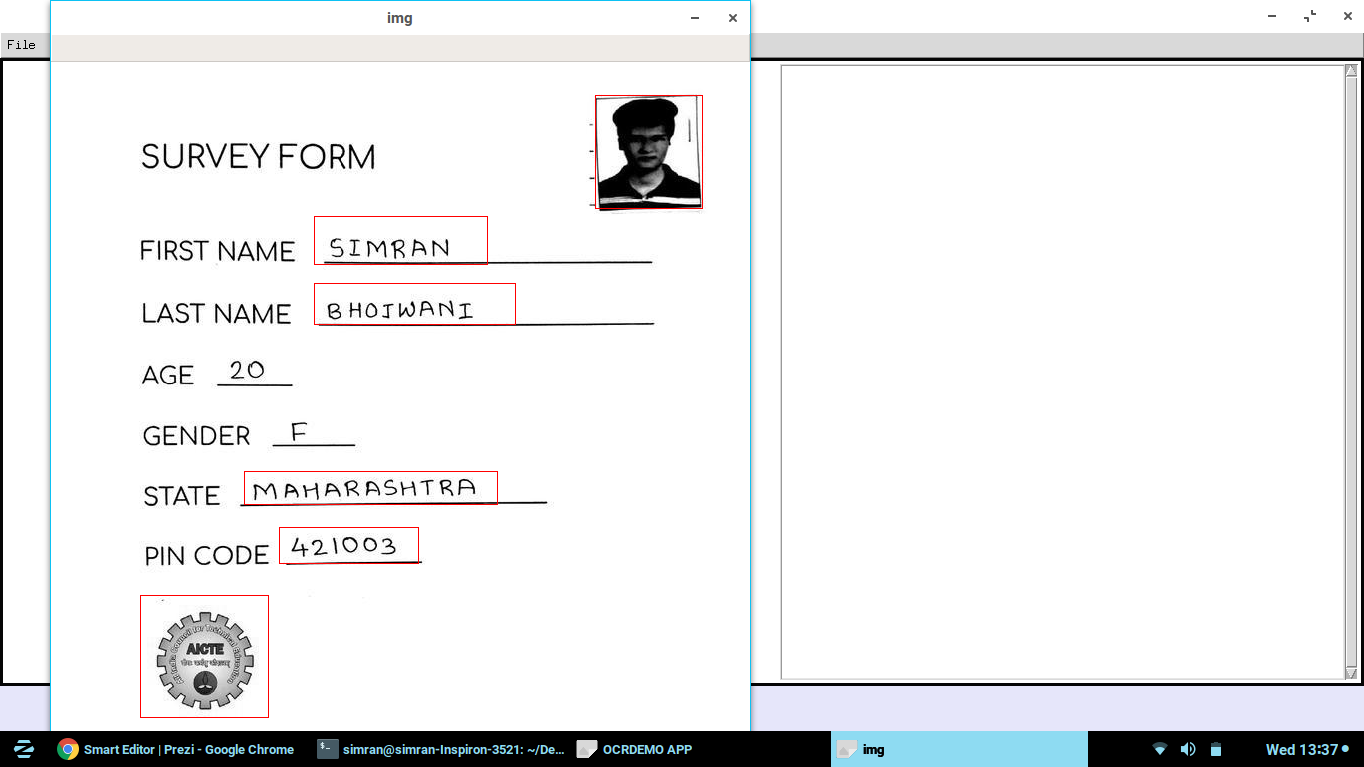 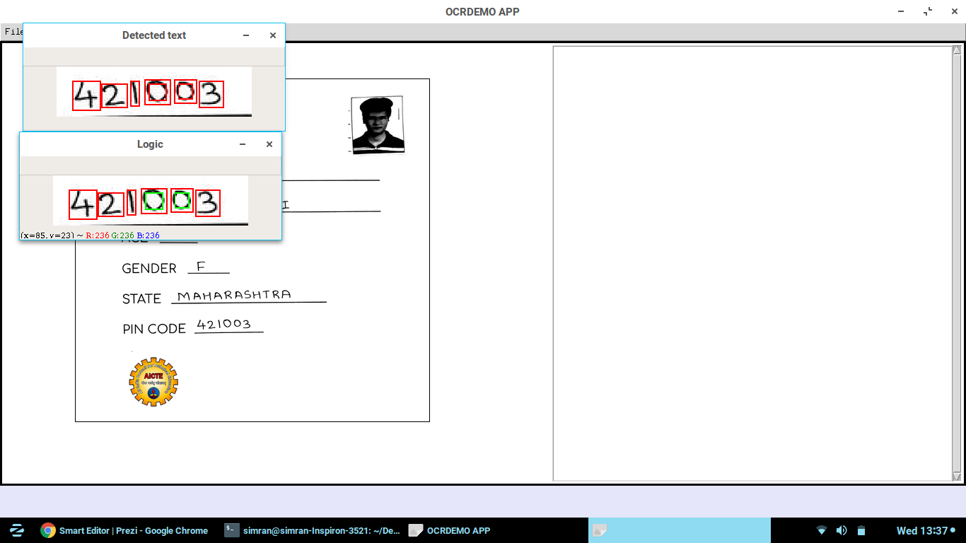

**Result**

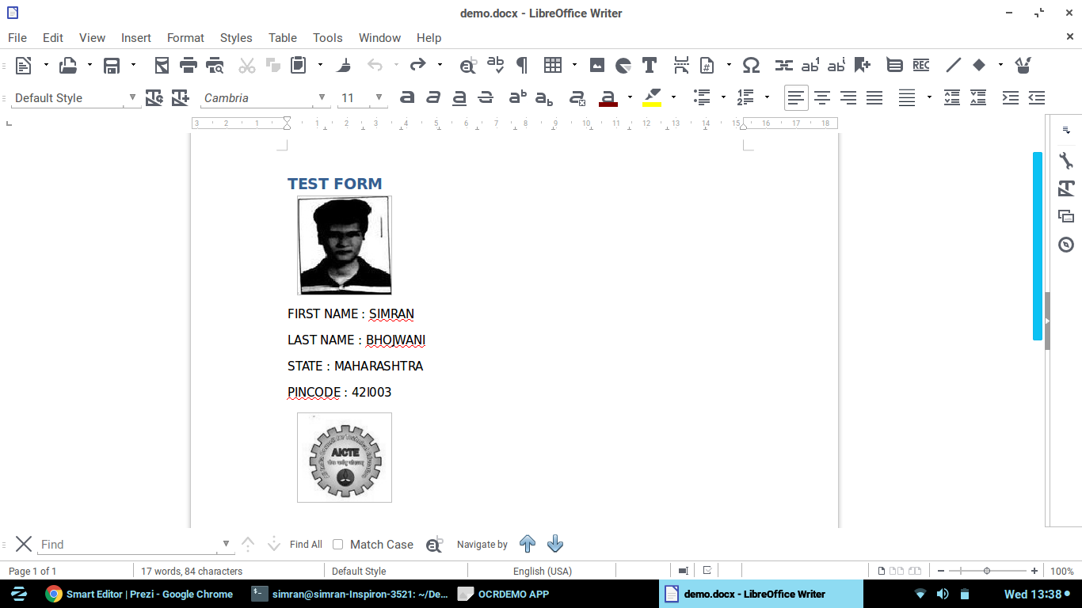

**Conclusions (Add Better conclusion if you want)**

Digital India mission various government organisations can convert the huge amount existing paper based data into digital one. Thus saving lot of time and human effort.

**References**

**(Add paper referred )**